The principles and use of common code inductance
Common mode inductance consisted of ferrite core is a common mode interference inhibitor. It is symmetrically wound on a ferrite T-core by same two coils in dimensions and turns in the form of a four-terminal component, which has a great inhibition to common mode inductance presented by common mode signals but merely doesn't work to small leakage inductance. What the principle is that magnetic flux in cores mutually piles up when current flows into common mode resulting in a deal amount of inductance as a inhibition to common mode current, opposite, when two coils flows into differential mode the magnetic flux in cores mutually counteracts and hardly inductance exists, that's why differential mode current can across it without reduction. So common mode inductance can efficiently restrain common mode from interfering and does not exert its influence on differential mode in normally transmission.
Below requirements should be met when common mode inductance is in-making;
1）mutual insulation of lead wires wound on core coils in order to guarantee that there is no puncture and short circuit in turn-to-turns of coils under the influence of transient overvoltage.
2）The core is not saturated if transient heavy overvoltage flows into coils.
3) Cores and coils should be mutually insulated, which prevents both of them are breakdown under the action of transient overvoltage.
4）Winding single layer as much as possible, which can reduce the parasitical capacitance of coils and reinforce the ability to withstand transient overvoltage.
Generally situation, spectrum of line filter is selected carefully, more larger impedance, more great. So components documents are important for us to choice common mode inductance because it is selected majorly on the basis of resistance frequency. Apart from that, the influence of differential mode impedance on signals is considered too. Mainly focus on differential mode impedance, especially take notice of high-speed port.
with waves of electrical devices, computer and home-used appliance and widely prevalence, noise disturbance from power grid becomes more and more serious and finally be a public hazard. Especially for still noise disturbance, it ups rapidly and lasts in a moment, with high voltage amplitude and randomness, which easily cause disturbance for microcomputer and digital circuit unconsciously. It has the home and aboard in circle of electric really concerned.

EMI Filter has been a new combined components promoted and applied recent years. Effectively inhibiting power grid noise and beefing up anti-disturbance of electric devices as well as reliability of system, it can be widely applied to electronic measurement instrument, computer house devices, switch power supply and measurement and control system.

1 The Aufbau principles and applications of EMI Filter
1.11 Aufbau principles
power supply noise is a kind of electromagnetic interference, its spectrum of conducting noise is about 10kHz~30MHz and it's up to Maximum 150MHz. According to different direction of transmission, it's separated from 2 types. different transmission direction can be classified into two parts: the first part is the external disturbance coming from power supply breakout; the second part is that the noise caused by electrical devices is conducted outwards through power supply wires, which signifies bidirectional disturbance signals. Electrical devices belong the target to be disturbed and also it is a noise source. For the view of forming features, noise is divided into chain mode interference and common mode interference. Chain mode interference is the noise between two power supply wires(line-to line), common mode interference is the noise of two power supply wires to earth(line-to-earth). Therefore, EMI filter is in accordance with EMC requirements and it is a must of bidirectional radio-frequency filter. On the one hand, external EMI coming from AC power supply breakout can be filtered; on the other hand, it can avoid giving away noise outwards saving others electrical devices from abnormal working under the same condition. Apart from that, EMI filter plays a part in inhibiting chain mode interference and common mode interference.

1.2 Typical appliance of basic circuit
The basic drawing of EMI filter as below figure

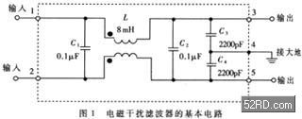

There are two input terminals, two output terminals and one earthing terminal in this component. When it is used, the housing should be earthed. The circuit incorporates common mode choke L, line filter capacitor C1~C4. L has no influence on chain mode interference but total inductance value increased by leap and bounds after coupling due to same magnetic flux direction of those two coils when there appears common mode interference. It shows great reactance to common mode interference ad make it difficult to go through, that's why it called "common mode choke coils". If two coils wound on Ferrite cores with low-loss and high magnetic conduction separately, their magnetic field will mutually strength. The inductance value of L in connected with the rated current I of EMI filter. Please have a look on chart 1.
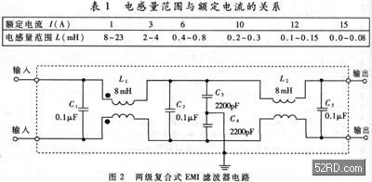

Need to mention it, when rated current is strong, the diameter of common mode choke coils should be bigger too so as to undertake strong current. Besides, low-frequency feature can be improved a lot if increasing inductance properly. C1 and C2 use thin film capacitor whose volume ranges from 0.01Μf to 0.47μFm, mainly adapted for filtering chain mode interference. C3 and C4 are connected in output terminal and earth the middle point of thin film capacitor which effectively suppress common mode interference. C3 and C4 also can be chained on the terminal of input, ceramic capacitor, ranging from 2200Pf to 0.1μF. For reducing leakage current, the volume of electrical capacitor is no more than 0.1μF and the middle point is earthed. The durable voltage value of C1~C4 is 630VDC or 250VAC, on average. It is a internal circuit of two-steps compound EMI filter. Owing to two steps filter adapted, a great noise-filtering effect is brought. Targeting at the problem of electrical fast transient with thousands KHz repeating frequency , group indicator appeared in domestic and aboard that can inhibit that interference mentioned above.
2 The appliance of EMI filter in switch power supply
To reduce the volume and cost, single-chip SMPS normally adapts easy single-polarity EMI filter. Typical circuit as drawing 3 below:
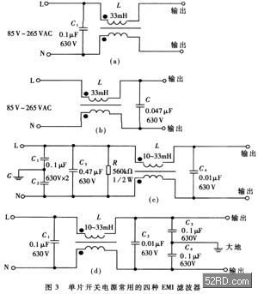

In Picture(a) and picture(b), capacitor C can filter chain mode interference out. And the only difference is that C is placed on input terminal in Picture(a) but on output terminal in Picture(b). In Picture (c）and (d), they show more complicated circuit and will result in more significant inhibition in interference. L, C1 and C2 in Picture(c) are used for filtering common mode interference out, C3 and C4 filter chain mode interference out. In order to discharge resistance, R has the ability to discharge the accumulated electric charge on the purpose of that the property of filter is affected by accumulated electric and makes sure that L and N, start wires of power supply, has no electricity after electricity cut off and ensures safely use. In Picture（d), common mode interference filter capacitor is docked with C3 and C4 input.
EMI filter can effectually inhibit single-chip electromagnetic interference generated by SMPS. Curve a in Picture(4) is waveform representing 0.15MHz~30MHz conductive noise on SMPS without no EMI filter. Curve b is a waveform that EMI filter inserted. Obviously, EMI filter work on reducing electromagnetic interference to 50dBμV~70dBμV.
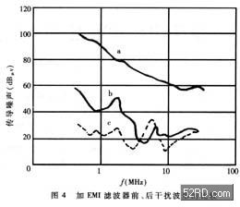

3. The testing methods and technical parameter of EMI filter
3.1 Main technical parameters
The main parameters of EMI has : rated voltage, rated current, leakage current, testing voltage, insulation resistance, DC resistance, recommended temperature range, working temperature rise(Tr), insertion loss AdB, appearance and dimensions, weight etc. The most significant parameter below is insertion loss, it is the major index to judge whether EMI filter is good or not. Insertion loss is the function of frequency, denoted by AdB. Hypothesis that noise power transmitted to load before or after EMI filter inserted respectively is P1、P2 , below is the formula：
AdB=10lg P1/P2
(1) Hypothesis that load resistance keeps same before or after being inserted, then P1=V12/Z，P2=V22/Z。In formula, V1 is the voltage that put onto load directly by noise source, V2 is noise voltage on load when and EMI filter inserted between noise source and load, plus V2＜＜V1。Put it to the formula, we can obtain:
AdB=20lg
(2) Insertion loss is represented by dB. more great of dB value , more stronger inhibition on noise interference. Because of sophisticated calculation theoretically gone with great errors, generally real measurements will be carried out to get correct insertion loss by virtue of noise spectrum point by point and then depict typical insertion loss curve, which is provided for clients.
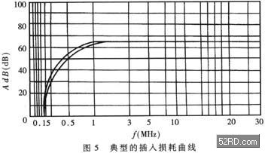

There is a typical curve in Picture 5. It can be seen that this product can reduce 1MHz~30MHz noise voltage to 65dB. The formula of EMI filter with earthed leakage current is as below
ILD=2πfCVC(3)
In this formula, ILD is leakage current, f is power grid frequency. Setting picture 1 as a example, f=50Hz, C=C3+C4=4400pF，VC is voltage drop on V3 and V4, that is, voltage to earth on output terminal, VC≈220V/2=110V. According to formula(3), we can get a result of leakage current ILD=0.15mA. If C3 / C4 is 4700pF, then C=4700pFX2=9400pF，ILD=0.32mA. Undoubtedly, leakage current is in direct proportion to C. It is the best for leakage current to be small, whose safety become higher. In electric medical devices, there are more serious and rigorous requirements for leakage current.
Need to point out, rated current is related to ambient temperature. For instance, below experienced formula was made
I=I1(4)
in this formula, I1represents rated current at temperature 40°C. When TA=50℃，I=0.88I1；but when TA=25℃，I=1.1511.what signify is that rated current goes up while temperature goes down. That's because of improved heat-dissipation condition.
3.2 Measurement approaches for insertion loss
Circuit for measuring insertion loss as below:
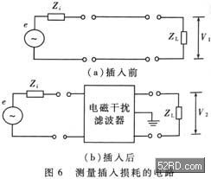

e is noise signal generator, Zi is internal resistance of noise source, ZL is load resistance. Frequency can be 10kHz~30MHz. Firstly under the different frequency measuring separately noise voltage drop V1/V2 on load before and after inserting, and putting them into formula （2）to calculate AdB value per frequency point, finally depicting insertion loss curve. The method below is complicated, EMI filter should be disassembled every time. Quick switch with electrical switch is necessary for those two kinds of testing circuits.

